3G150B-How to limit the computer to access the Internet by client Filter function?
Product line:3G Question category: Function configarations

Q：Why we should configure Client Filter?
A：To benefit your further management to the computers in the LAN, you can control some PCs with certain IP address access to Internet by setting Client filter to achieve it.
Note: you only can set the Client Filter when the 3G150B is in 3G Router mode or Router mode.
The Topology is as below:
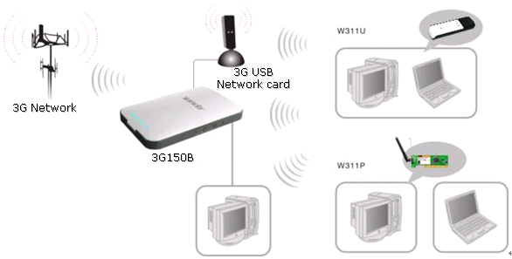
The steps are as below:
1．Login the management page of the router.
2．Click Security Settings→Client Filter. The client filter is disable default. 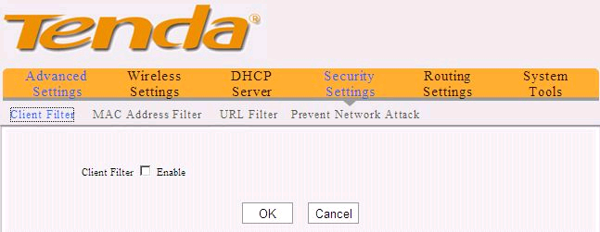
Tick the Enable to enable the Client Filter.
For example, we want to limit the computer with IP address during 192.168.2.100~192.168.2.200 to access the internet from 8:00am to 18:00pm from Monday to Friday. And the computer with other IP address can access Internet. You can set the router following the picture as below.
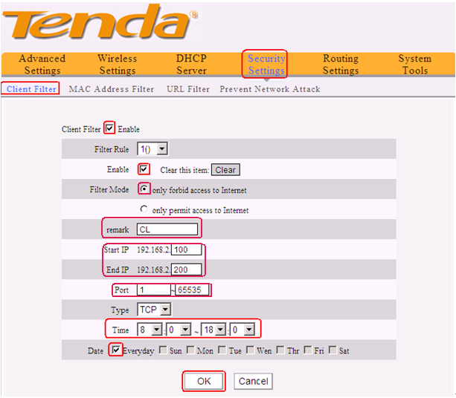
On the contrary，you only want the computers with IP address during 192.168.2.100~192.168.2.200 to access the internet from 8:00am to 18:00pm from Monday to Friday and others can’t access Internet. You can set the router following the picture as below.

